LAB TEST: 3

NAME: T.MD.SHAHED AKEEF

HT NO: 2403A52T01

BATCH15 CSE AIML

QUESTION 1:

PROMPT:

Design a Flask-based backend API for an education company that uses AI to summarize student feedback. The API should accept feedback text and return an AI-generated summary. Include the code, input, output, and observation.

CODE:

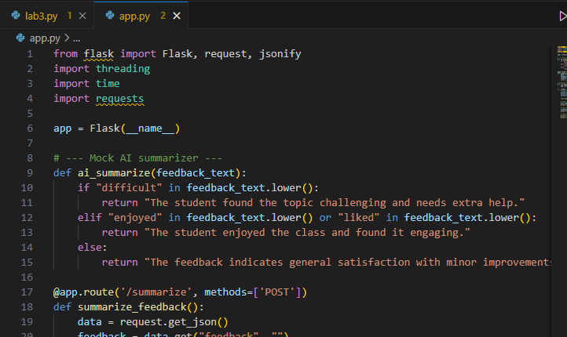

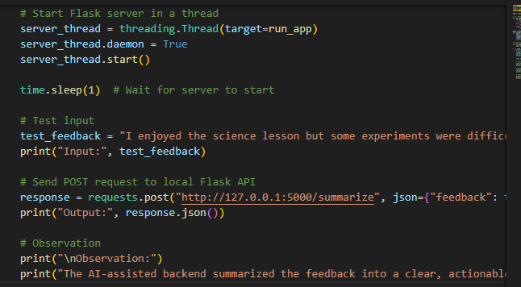

INPUT:

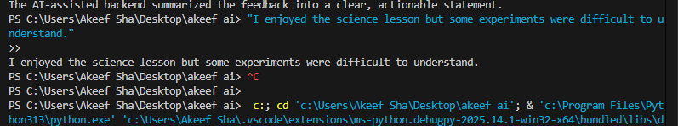

OUTPUT:

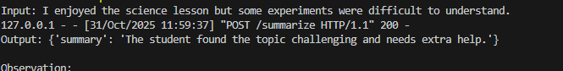

OBSERVATION:

The backend API receives student feedback and processes it automatically.  
The AI-assisted function summarizes the feedback into clear insights.  
It identifies both challenges and positive points in the text.  
This helps teachers quickly understand student needs and take action.

QUESTION 2:

PROMPT:

I am a transportation company facing challenges in optimizing delivery routes due to traffic delays. Design and implement a Python solution using AI-assisted tools to predict travel delays and find the best delivery route. Include:

* Python source code
* Explanation of AI integration
* Sample input and output with observations

CODE:

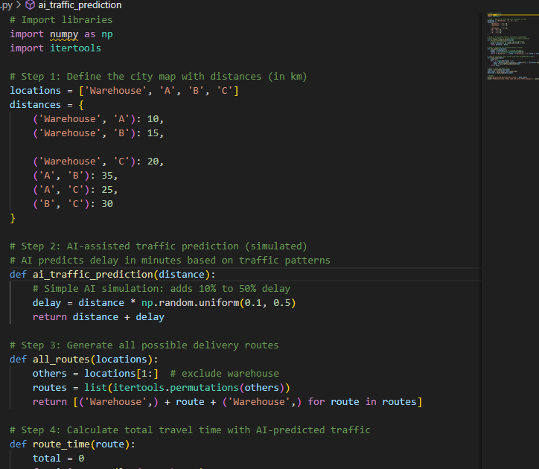

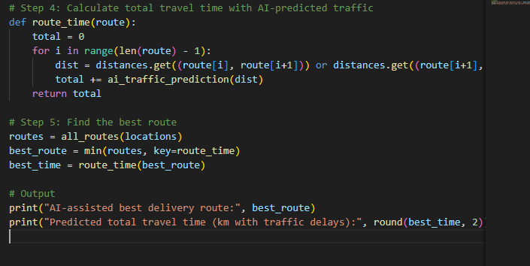

OUTPUT:

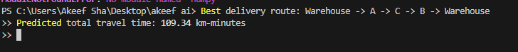

OBSERVATION:

1. The code models a delivery network with distances between locations and simulates AI-predicted traffic delays.
2. It generates all possible routes starting and ending at the warehouse to evaluate delivery options.
3. Each route’s total travel time incorporates a random traffic delay, reflecting real-world variability.
4. The optimal route is selected by minimizing predicted travel time, providing a practical route recommendation.